A Tutorial on the Development of Software V0.1 for Agent Based Modelling of Smoking Behaviours
David Tian
University of Sheffield

Contents
1. Introduction of Software V0.1 2
2. The Description of the Simulation 3
3. Designing the Architecture of Software V0.1 using Object-oriented Design Approach 3
3.1 Defining Subclasses of Model, MicroAgent, TheoryMediator and Theory Classes 4
3.2 Integrate Repast4Py Classes Into The Software Architecture 5
3.3 Add the Main Module 6
4. Installation of Python 3, pip, MPI, venv and Repast4py 6
5. Implementing Software V0.1 in Python based on The Class Diagram (Figure 4) 7
6. Example Runs 10

Introduction of Software V0.1

Software V0.1 simulates the monthly smoking behaviours of a 16+ years old population in England over 1 year period. At the beginning of the simulation, an agent is created for each individual of the population. An agent has 4 characteristics: age, sex, IMD quintile and a state (smoker, quitter, ex-smoker or never smoker). A time step represents a month. At each time step, the smoking behaviour of each agent is modelled based on the MBSSM (Mechanism-based Social Systems Modelling) framework (Figure 1) [1] which models the influences between social entities (macro and micro entities) using 4 mechanisms:
- Situation mechanism: a macro entity (e.g. smoking intervention) changes the states of a micro entity (e.g. an agent).
- Action mechanism: a micro entity do actions based on its state.
- Transformational mechanism: The collective actions of micro entities influence macro entities.
- Macro-macro mechanism: a macro entity influences another macro entity.

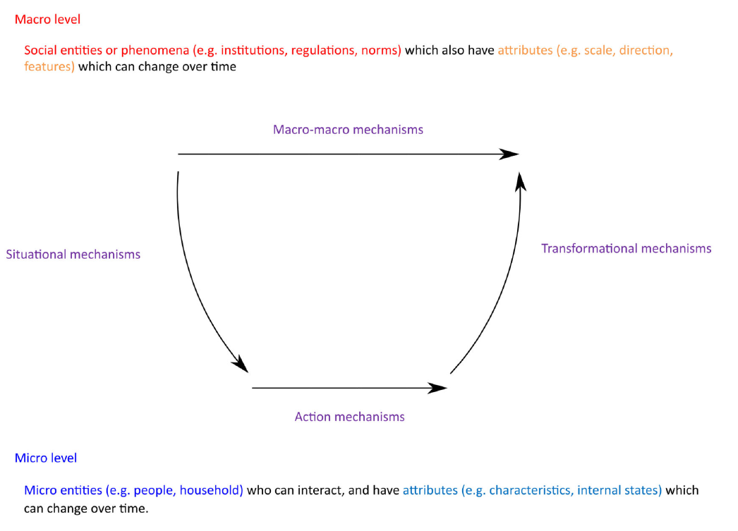
Figure 1: the MBSSM (Mechanism-based Social Systems Modelling) framework

The Description of the Simulation

The steps of the simulation are as follows:
- Initialize a population of agents to the STAPM 2012 data.
- At each time step T (T=1,…,12),
- Run the situational mechanism of each agent as follows:
If intervention is ON
capability = effect size of intervention
Else
capability=1
End
- Run the action mechanism of each agent as follows:
- Set the variable intention_to_quit to a random number drawn from the Normal(0,1).

If agent is a smoker at T-1 and capability x intention_to_quit >= threshold
The agent is a quitter at T
Else
The state of agent is the same as its state at T-1
End
- Calculate and display the smoking prevalence (percentage of smokers) of the current population of agents.
The input data is the STAPM 2012 data of age >=16 people. STAPM 2012 data is a pre-processed data of the Health Survey England (HSE) 2012 data.
The parameters of the simulation are the intervention, the effect size of intervention and the threshold set by the user; intervention is either ON or OFF; the threshold is a value > 0 and < 1; the effect size of intervention is a value > 0 and <10.
- Setting effect size of intervention to a value >1 represents that intervention is used which increases the intention to quit.
- Setting effect size of intervention to a value < 1 represents that intervention is used which decreases the intention to quit.
- Setting effect size of intervention to 1 represents that intervention is OFF.

Designing the Architecture of Software V0.1 using Object-oriented Design Approach

Vu et al. [1] proposed a software architecture for the MBSSM (Figure 2). The MBSSM software architecture is an object-oriented software structure [2] which consists of the 7 classes: Model, Micro-Agent, TheoryMediator, Theory, StructuralEntity, StructuralMediator and Regulator. Model is responsible for initializing a population of agents and run the simulation. The MicroAgent class represents agents. Theory consists of different types of mechanisms of an agent such as situation mechanism and action mechanism. TheoryMediator decides which mechanism(s) to run. A MicroAgent instance has a TheoryMediator instance which has 1 or more Theory instances. Each Theory instance is associated with a MicroAgent instance. StructuralEntity represents a macro entity such as social network. Regulator performs macro-macro mechanism. StructuralMediator decides which mechanism to run.

Figure 2: UML Class diagram [3, 4] of MBSSM software architecture

3.1 Defining Subclasses of Model, MicroAgent, TheoryMediator and Theory Classes

The software V0.1 is designed based on the MBSSM software architecture. In order to simulate smoking behaviours, subclasses of Model, MicroAgent, TheoryMediator and Theory are defined as follows:

- SmokingModel is a subclass of Model so that SmokingModel inherits the attributes and operations of Model. Additionally, an effectSize attribute and getEffectSize operation are defined in SmokingModel to model the effect of the intervention on intention to quit.
- Person is a subclass of MicroAgent so that Person inherits the attributes and operations of MicroAgent. Additionally, Person has a list of states representing the states of the Person at different time steps and the attributes sex, age and IMD quintiles.
- SmokingTheoryMediator is a subclass of TheoryMediator so that SmokingTheoryMediator inherits the attributes and operations of TheoryMediator.
- QuitTheory is a subclass of Theory so that QuitTheory inherits the attributes and operations of Theory. Additionally, QuitTheory has attributes probability_of_quit, capability, opportunity, motivation and smokingModel.

The class diagram of software v0.1 is shown in Figure 3.

Figure 3: Class diagram of the software v0.1

3.2 Integrating Repast4Py Classes Into The Software Architecture

Repast4py [5] is an agent-based modelling library in Python. Three of the classes of Repast4py are SharedScheduleRunner, SharedContext and Agent classes. SharedScheduleRunner schedules execution of events at each time step. SharedContext represents a population of agents. Agent class represents a Repast4py agent. The id of a Repast4py agent consists of 3 components: id, type of agent and the process rank of the agent. The id is an integer unique to the agent; type is an integer representing the type of the agent; rank is the id of the process creating the agent. In this tutorial, there is a single type of agents and the type can be set to 0; the simulation is run on 1 process and the rank is set to 0. SharedScheduleRunner and SharedContext are added to Model as attributes (Figure 4). MicroAgent is defined a subclass of Repast4py agent so that MicroAgent inherits the id of a Repast4py agent. SharedContext has numerous MicroAgents.

Figure 4: Class diagram of the software v0.1 with Repast4py classes integrated

3.3 Adding the Main Module

In order to run the software, the main module is called by the user on the command line. Main reads the input data file name (STAPM 2012 data file) and the parameters of the simulation from a file. Then, Main starts the simulation by invoking the methods of SmokingModel (Figure 5).

Figure 5: The final class diagram of the software v0.1 with main module

Installation of Python 3, pip, MPI, venv and Repast4py

Repast4py can only be installed on linux or macOS operating systems. To install Repast4py on Windows 10 operating system, Windows Subsystem for Linux (WSL) can be firstly installed on Windows 10, then Repast4py can be installed on the WSL in the same way as installing it on Ubuntu linux (described below).
https://en.wikipedia.org/wiki/Windows_Subsystem_for_Linux
https://learn.microsoft.com/en-us/windows/wsl/about
Install python 3, pip, MPI, venv and Repast4py on Ubuntu linux in the following order:
- Keep your Ubuntu linux with the latest packages by running the following two commands:
sudo apt update
sudo apt upgrade
- Install python 3 if it is not available on your platform e.g. Ubuntu linux:
https://www.makeuseof.com/install-python-ubuntu/
- Install pip for python 3:
apt install python3-pip
- Install MPI on your platform (linux or macOS):
https://repast.github.io/repast4py.site/guide/user_guide.html
- Install venv to create virtual environment for Python 3:
apt install python3-venv
Then, create a virtual environment:
python3 -m venv my_env
More details on creating virtual environment is at:
https://linuxopsys.com/topics/create-python-virtual-environment-on-ubuntu
- Install Repast4py in the virtual environment that you created:

- Activate the virtual environment:
source my_env/bin/activate

- Install Repast4py in the virtual environment:

env CC=mpicxx pip install repast4py

Implementing Software V0.1 in Python based on The Class Diagram (Figure 4)

The Bitbucket repository of software v0.1 is at:

https://co1dtx@bitbucket.org/co1dtx/abm-software-v0.1.git
Download the repository to a directory on your computer e.g. D:/downloads
The ‘D:/downloads/ co1dtx-abm-software-v0.1-3bc1dd0542d8/code_v0_1_tutorial’ folder contains the skeleton code of software V0.1. Open Person_and_SmokingModel.py using a source code editor e.g. VS Code (https://code.visualstudio.com/download)
In VS code, select File -> Open Folder to open ‘code_v0_1_tutorial’:
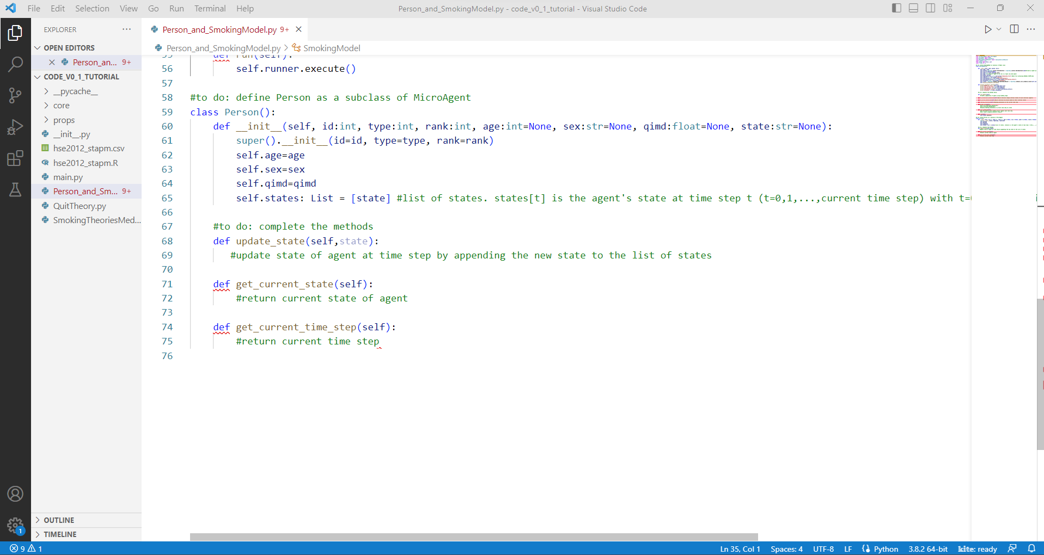
Implement the Person class by following the ‘#to do’ hints. If you don’t have knowledge of Python programming, copy and paste the implementation of Person class from Person_and_SmokingModel.py under folder ‘co1dtx-abm-software-v0.1-3bc1dd0542d8’:
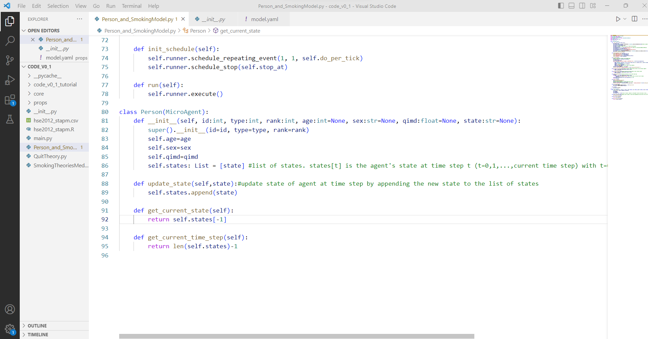
Implement SmokingModel class by following the ‘#to do’ hints. If you don’t have knowledge of Python programming, copy and paste the implementation of SmokingModel class from Person_and_SmokingModel.py under folder ‘co1dtx-abm-software-v0.1-3bc1dd0542d8’.

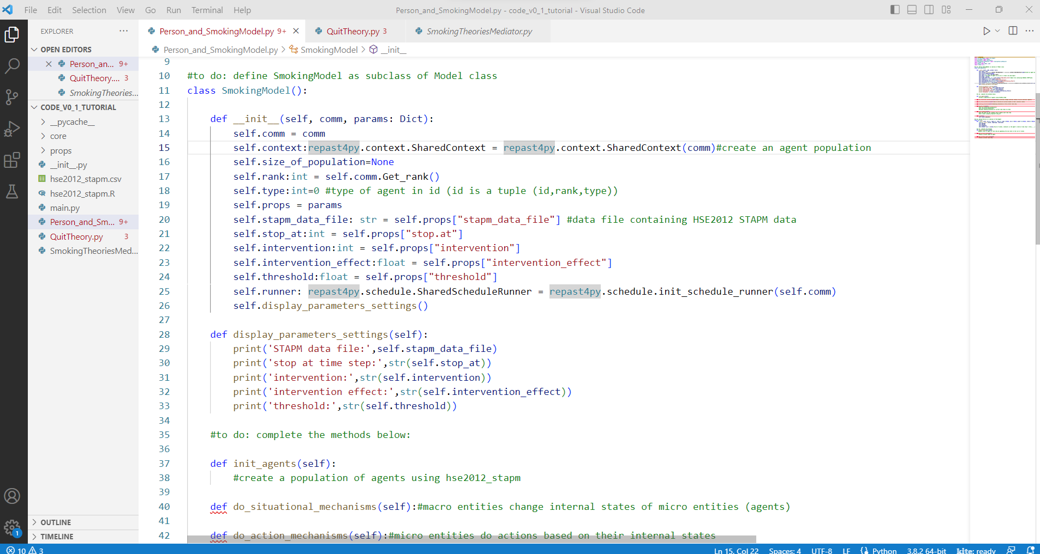
Implement QuitTheory class by following the ‘#to do’ hints. If you don’t have knowledge of Python programming, copy and paste the implementation of QuitTheory class from QuitTheory.py under folder ‘co1dtx-abm-software-v0.1-3bc1dd0542d8’.
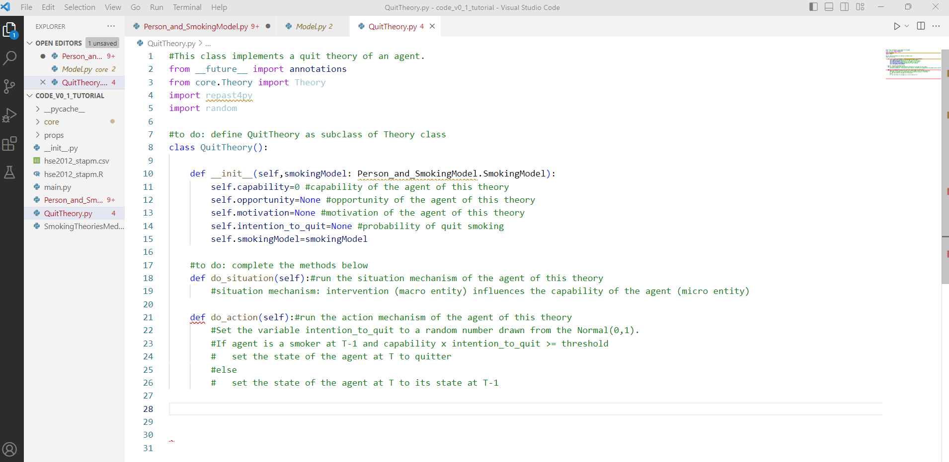
Implement SmokingTheoriesMediator class by following the ‘#to do’ hints. If you don’t have knowledge of Python programming, copy and paste the implementation of SmokingTheoriesMediator class from SmokingTheoriesMediator.py under folder ‘co1dtx-abm-software-v0.1-3bc1dd0542d8’.
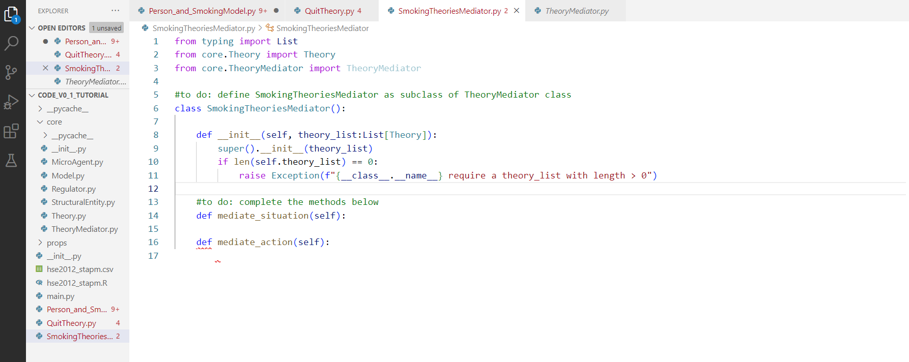
References on OOP in Python:
https://www.tutorialspoint.com/python/python_classes_objects.htm
https://www.w3schools.com/python/python_classes.asp

Example Runs

main.py is called on the command line with model.yaml file passed as input. model.yaml contains the following settings of the parameters of the simulation and is under the props directory.
- stapm_data_file: hse2012_stapm.csv
- stop.at: 12
- intervention: 0
- intervention_effect: 2
- threshold: 0.7
hse2012_stapm.csv is the STAPM 2012 data:
"age","sex","qimd","state"
58,"female",2,"never_smoker"
47,"male",2,"never_smoker"
39,"male",3,"never_smoker"
41,"male",1,"ex-smoker"
37,"female",1,"ex-smoker"
51,"male",1,"ex-smoker"
48,"female",1,"ex-smoker"
19,"male",1,"never_smoker"
…

Run1
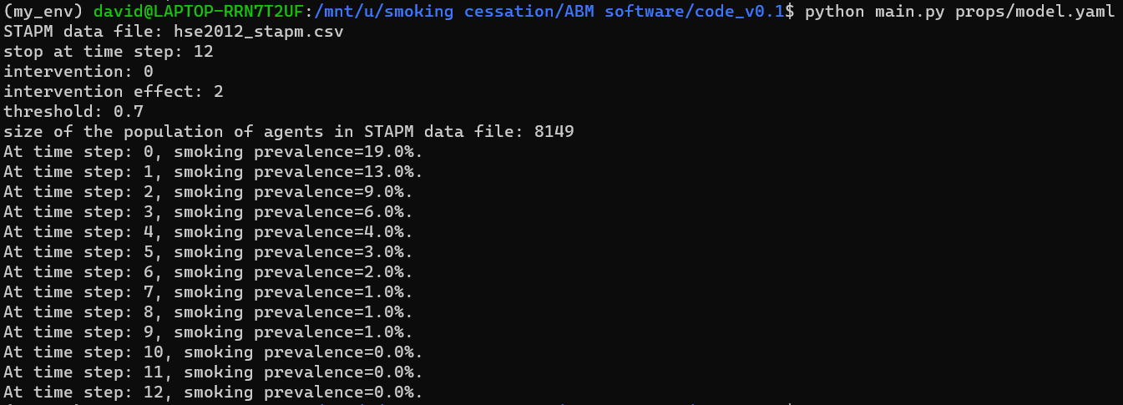

Run2
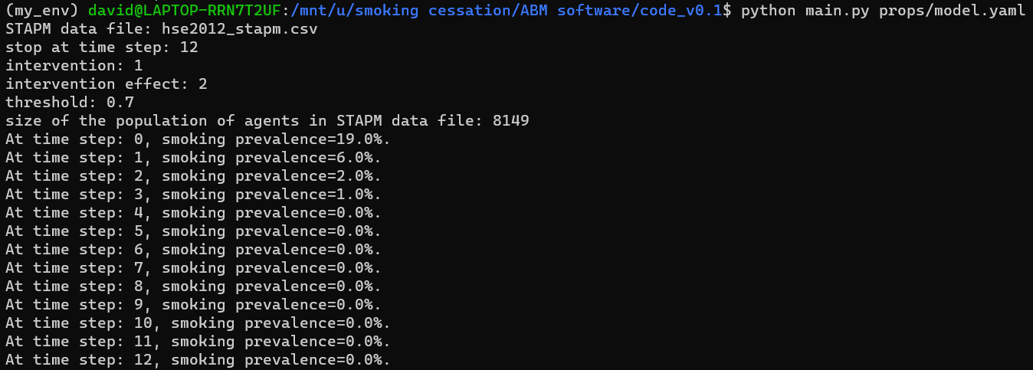

Reference:
[1] Vu et al. A software architecture for mechanism-based social systems modelling in agent-based simulation models. Journal of Artificial Societies and Social Simulation, 2020; 23(3):1
[2] https://en.wikipedia.org/wiki/Object-oriented_design
[3] https://en.wikipedia.org/wiki/Class_diagram
[4] https://en.wikipedia.org/wiki/Unified_Modeling_Language
[5] https://repast.github.io/repast4py.site/index.html

